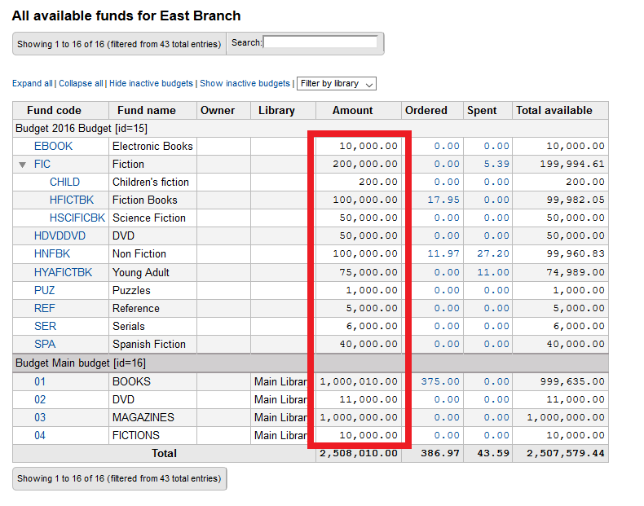
Turn the numbers in the ‘Amount’ column to links that take you the modify Fund page or you can go directly to the modify fund page (Fund -> Action button -> Edit).

This is what the page currently looks like:
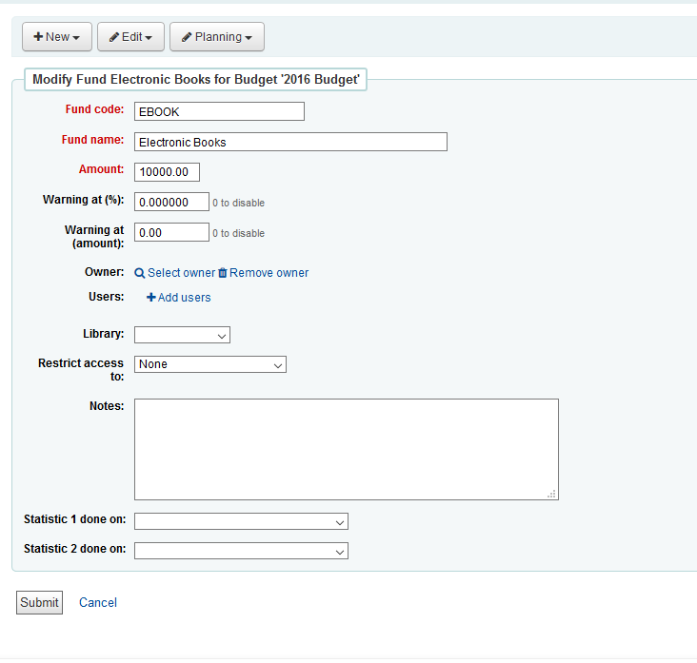

The page might look something like this:
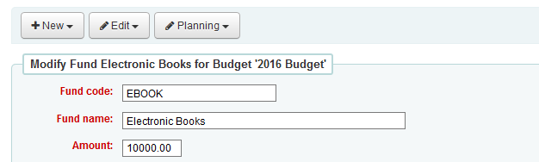
The active fund drop down shows up if ‘Transfer to’ is selected.
Fund Amount: $10,500.00
Modify Fund Amount:
Add
Subtract
Transfer to
In the case of a transfer, the ‘transfer to’ fund would need its Fund Amount and History updated.
Active funds
Modify Amount:
Reason:
Modify

Date (Take system date or input date?) | Increase/Decrease | Fund Amount | Reason for change
12/19/2019 | $500.00 (+) | 10,500.00 | Donation for Digital collection
10/01/2019 |  | 10,000.00 | Initial Budget
History:
Page loads with History collapsed.
